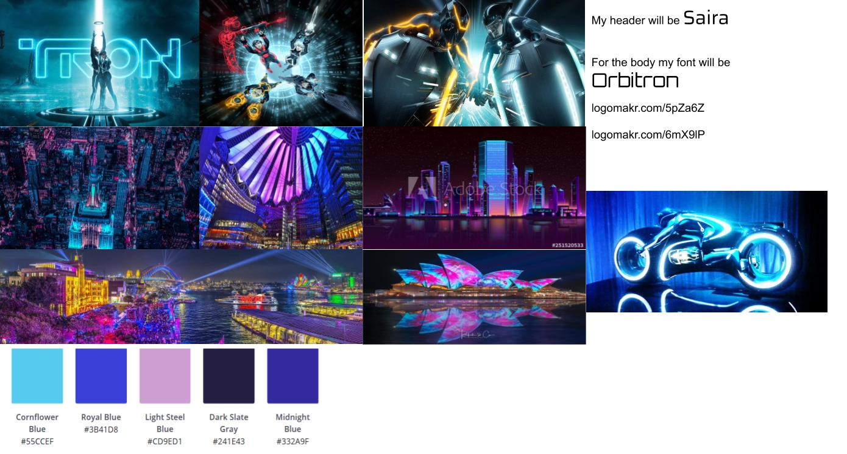

Flynn’s Website

POrtfolio

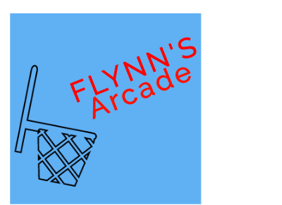Brock Millar| 13/9/2019

Contents

Design Brief 2

Areas of investigation/Research 2

Design Sketches 2

Final concept/Design 2

Design changes 2

Evaluation 2

Bibliography 2

### 

## Design Brief

To replace the placeholder text on this page, you can just select it all and then start typing. But don’t do that just yet!

First check out a few tips to help you quickly format your report. You might be amazed at how easy it is.

* Need a heading? On the Home tab, in the Styles gallery, just click the heading style you want.
* Notice other styles in that gallery as well, such as for a quote, a numbered list, or a bulleted list like this one.
* For best results when selecting text to copy or edit, don’t include space to the left or right of the characters in your selection.

## Areas of investigation/Research

You might like the photo on the cover page as much as we do, but if it’s not ideal for your report, it’s easy to replace it with your own.

Just delete the placeholder picture. Then, on the Insert tab, click Picture to select one from your files.

## Design Sketches

## Final concept/Design

## Design changes

## Evaluation

## Bibliography